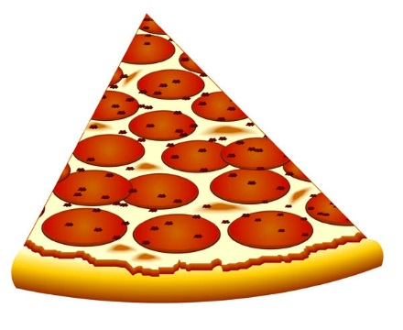 PIZZA PARTY!

*

*

MUST REGISTER BY THURSDAY, 08/24/17

770-962-5867

**WHEN:** 6:00pm-10:00pm

**WHERE:** Right here at GGA! 98

Patterson Road, Lawrenceville, GA

**Cost:** Members- $20 1st child, $18 2nd child

Non-Members- $25 each child

Register quick to reserve your spot for the pizza party at **KIDZ NIGHT OUT** on Saturday, August 26, 2017!